Chapter 17, Problem 3.

Give the Fourier coefficients a₀, a_{n}, and b_{n} of the waveform in Fig. 17.47. Plot the amplitude and phase spectra.

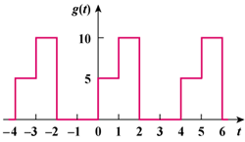

Figure 17.47
For Prob. 17.3.

